EXHIBIT E
New Site, Expansion, Large Renovation, and Relocation Fees
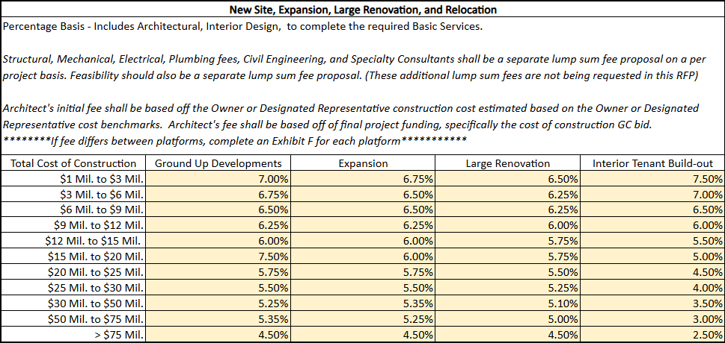
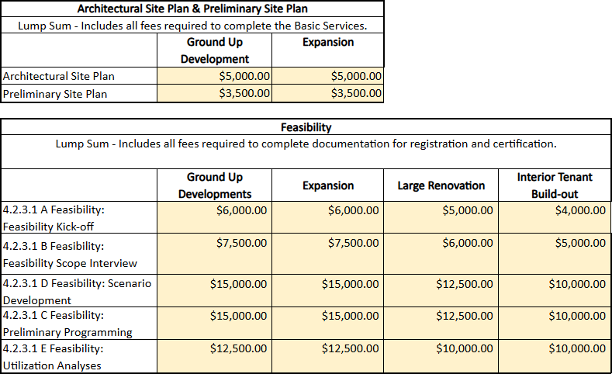

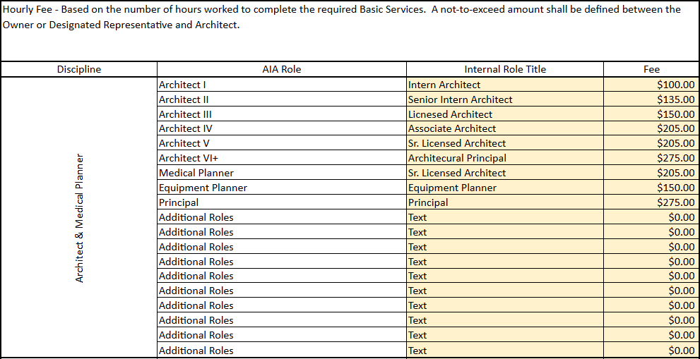
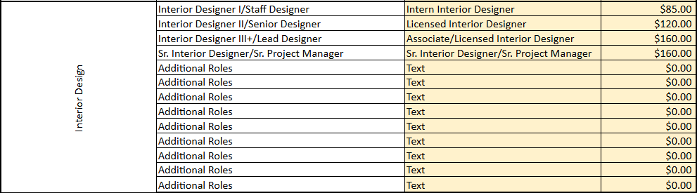
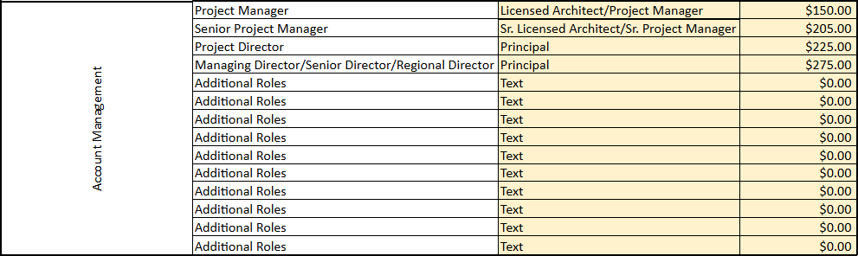

EXHIBIT F
Small Remodels, Contraction, or Split Relocation Project Fees
Price per Square foot by project type and project size (of affected project area) for the Basic Services that may be required during the below listed project delivery types
All projects that exceed 10,000 SF of affected area should be priced within the percentage basis in Exhibit E
